Vcp creation
Creating an vpc
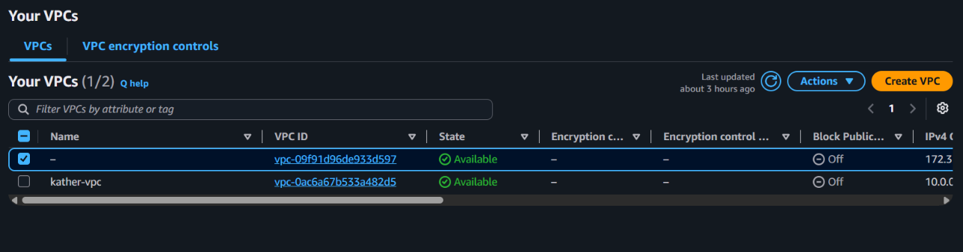

Creating two subnets
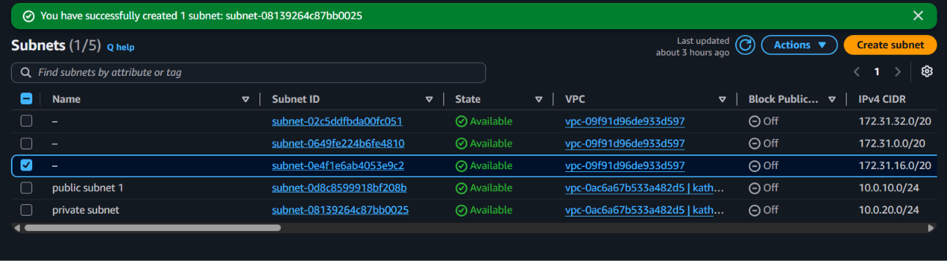

Creating an internet gateway
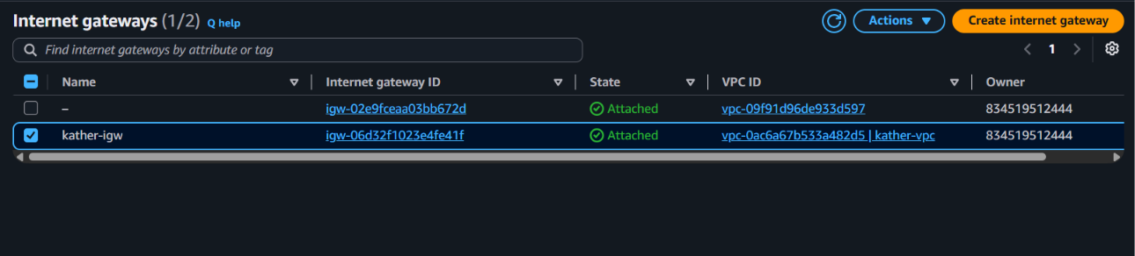

Create an nat gateway with elastic ip
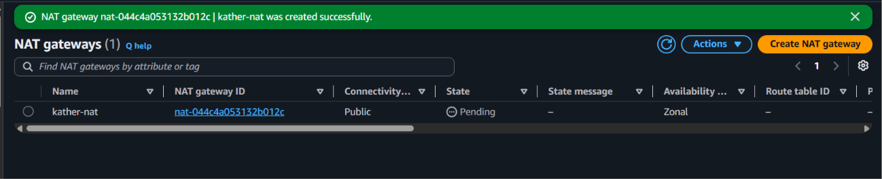

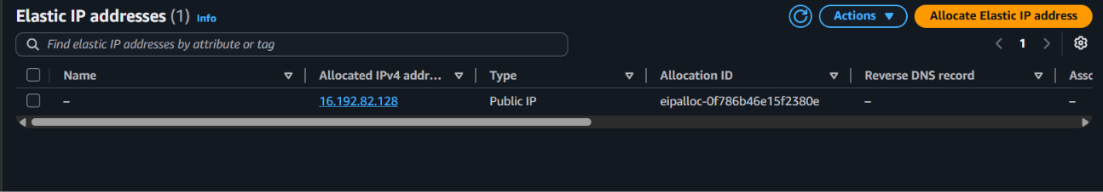

Create two route table
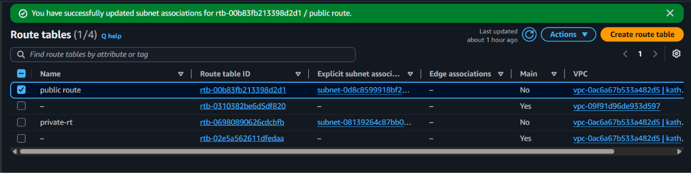

Create two separate route tables
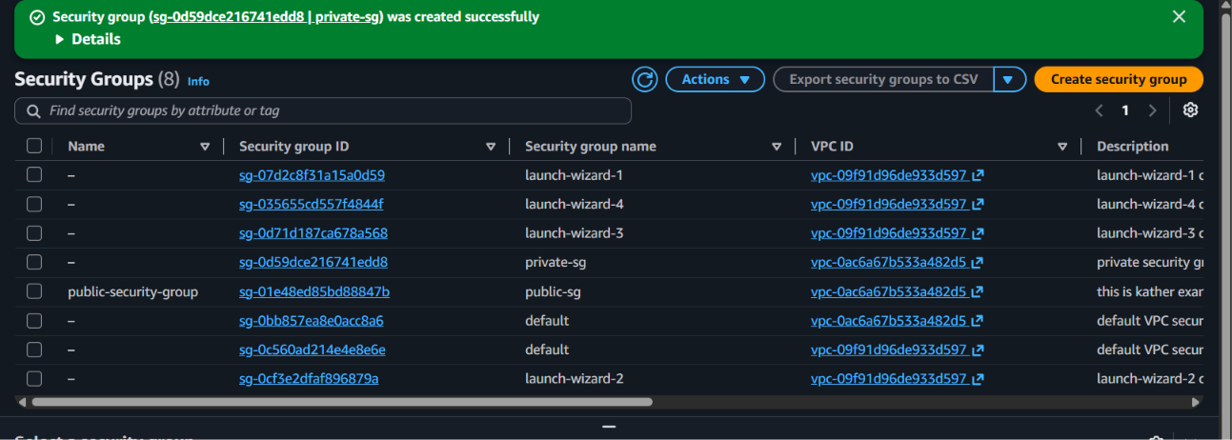

Create two separate ec2 instance
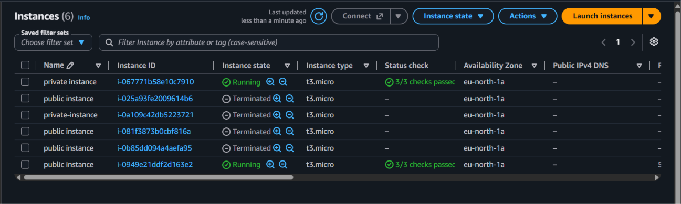
Connect using putty before that add the ppk to pagent
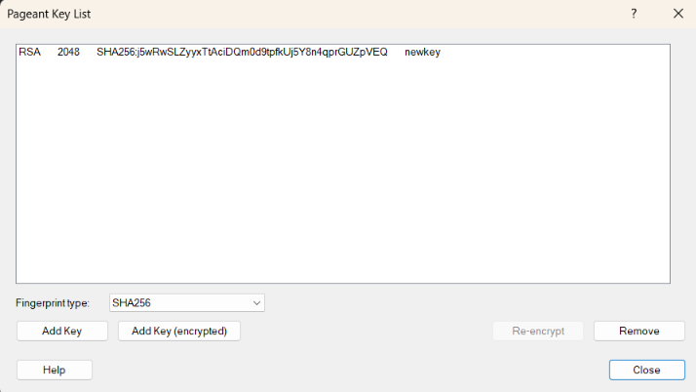

Connect to the putty with the agent forwarding enabled open the linux and check it
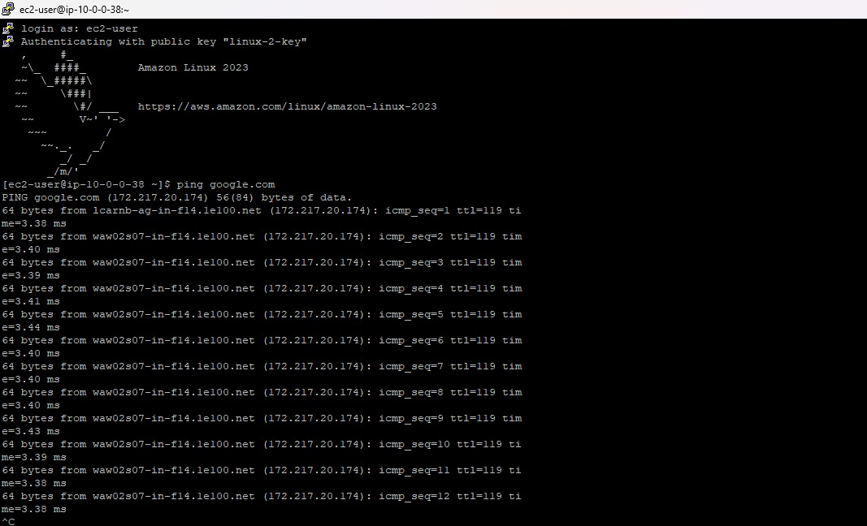

Then connect to the private instance
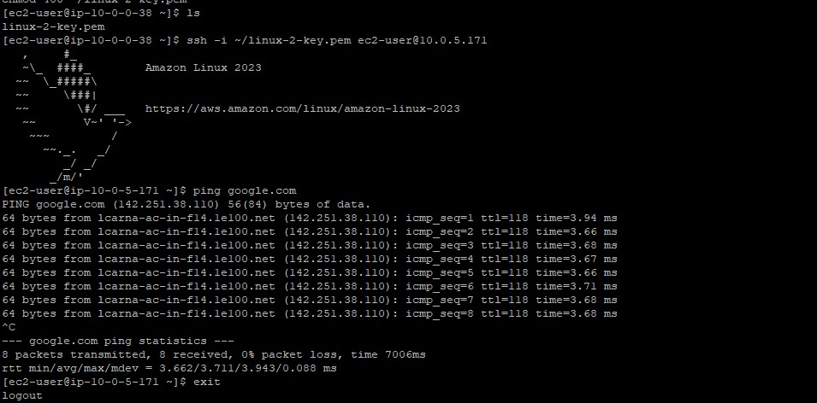

Deploy and output info from an index file



